CHAPTER 1
TASK PERFORMED
The internship was for a duration of 4 weeks. The day wise description of the topics covered during the internship is as follows:
Introduction to Networking:
Networking is the practice of linking two or more computing devices together for the purpose of sharing data. A network, is a collection of computers and other hardware components interconnected by communication channels that allow sharing of resources and information.
Types of Networks:
Local Area Network (LAN):
A LAN connects network devices over a relatively short distance. A networked office building, school, or home usually contains a single LAN, though sometimes one building will contain a few small LANs (perhaps one per room), and occasionally a LAN will span a group of nearby buildings. In TCP/IP networking, a LAN is often but not always implemented as a single IP subnet.

Wide Area Network (WAN):
As the term implies, a WAN spans a large physical distance. The internet is the largest WAN, spanning the Earth. A WAN is a geographically-dispersed collection of LANs. A network device called a router connects LANs to a WAN. In IP networking, the router maintains both a LAN address and a WAN address. A WAN differs from a LAN in several important ways. Most WANs (like the internet) aren't owned by any one organization but rather exist under collective or distributed ownership and management. WANs tend to use technology like ATM, Frame Relay, and X.25 for connectivity over the longer distances.
Metropolitan Area Network (MAN):
A network spanning a physical area larger than a LAN but smaller than a WAN, such as a city. A MAN is typically owned and operated by a single entity such as a government body or large corporation. It is a network that interconnects users with computer resources in a geographic area or region larger than that covered by even a large local area network (LAN) but smaller than the area covered by a wide area network (WAN).

PING:
Ping is a basic Internet program that allows a user to verify that a particular IP address exists and can accept requests. Ping is used diagnostically to ensure that a host computer the user is trying to reach is actually operating. Ping works by sending an Internet Control Message Protocol (ICMP) Echo Request to a specified interface on the network and waiting for a reply. Ping can be used for troubleshooting to test connectivity and determine response time.
Tracing IP Address:
Using IP Lookup
- Find the IP address that you want to trace. You can find a website's IP address on Windows, Mac, iPhone, and Android platforms.
- Click the search bar. This is the white box below the "IP Address or Hostname" heading.
- Type in the IP address that you found.
- Click Lookup IP
- Review the results.

Windows Firewall & Security:
Windows Firewall is a Microsoft Windows application that filters information coming to your system from the Internet and blocking potentially harmful programs. The software blocks most programs from communicating through the firewall. Users simply add a program to the list of allowed programs to allow it to communicate through the firewall. When using a public network, Windows Firewall can also secure the system by blocking all unsolicited attempts to connect to your computer.

CREATION OF BATCH VIRUS:
A batch file is an unformatted text file or script file which contains multiple commands to achieve a certain task. It contains series of command that is executed by command line interpreter and file extensions: is .bat or .cmd. The instructions in batch files are for automating repetitive command sequences.

Spoofing:

Spoofing is the act of disguising a communication from an unknown source as being from a known, trusted source. One of the best examples is: Caller ID spoofing.
Caller ID Spoofing: With caller ID spoofing, attackers can make it appear as if their phone calls are coming from a specific number either one that is known and/or trusted to the recipient, or one that indicates a specific geographic location. Attackers can then use social engineering often posing as someone from a bank or customer support—to convince their targets to, over the phone, provide sensitive information such as passwords, account information, social security numbers, and more.
CHAPTER 2
INTRODUCTION
In the 6th semester break, I did an internship at E-mind Technologies. Participating in a Workshop on Network Security followed by project development in each domain.
2.1 BRIEF INTRODUCTION ABOUT THE PROJECT:
The increase in Wi-Fi usage has led to increased wireless attacks. Any attack on wireless networks or access points which provides substantial information is referred to as wireless hacking. This information can be in the form of Wi-Fi passwords, admin portal access, authentication attacks etc. To understand wireless hacking, one of the most important things to understand are the protocols involved in wireless networks. Attacks are mostly made on the internal steps of the protocol stack. IEEE 802.11 specifies the standards for wireless networks.
Attacking Techniques:
- WEP cracking technique: WEP uses a 40-bit key which is 8 characters long. Once enough data packets are captured, breaking this key should not take more than a few minutes.

- WPA/WPA2 cracking technique: Our devices have wireless passwords stored so that we do not enter the password on the same device again and again. The attackers take advantage of this by forcefully de-authenticating all the devices on the network. The devices will try to auto-connect to the access point by completing the 4-way handshake. This handshake is recorded and has the hashed password. The hashed password can be brute forced by using a rainbow table.

- WPS cracking: This technology uses an 8-digit pin to connect to the wireless router. Brute forcing the 8-digit pin will give access to the router. Various tools use various optimization techniques to increase the speed of this attack and crack the key in a couple of hours.

2.2 OBJECTIVES:
- Provide overview of Internet Security
- To familiarize about the anti-virus, anti-spam and anti-spyware tools currently available
- To learn the latest Internet security techniques, firewalls & tools etc.
- To provide a basic knowledge of ethical hacking
- Understanding of wireless technologies.
- Describe wireless networking standards
- Describe the process of authentication & Bypassing authentication.
- Implement Cybersecurity Best Practices and Risk Management
- Describe wireless hacking and tools used by hackers and security professionals
- Impact Cybersecurity Risk in an Ethical, Social, and Professional Manner

CHAPTER 3
ROLE OF THE STUDENT IN INTERNSHIP

#3
3.1 Student Role
As an Intern during the internship period I successfully carried out the implementation of the project in hacking wireless devices according to steps required for cracking the passwords of several wireless devices and determining the tools and methods the were effective and efficient to crack the password.
3.2 Student Activities
- Learning & Understanding the technologies and tools that comes under wireless devices are taught by the instructor and doing the hands-on projects with the guidance of the instructor.

- Learning the tools and methods required for project such as
- Kali Linux
- Aircrack-ng, Wifite, Wifite 2.

- Worked on the Project Report and Design of our Project

- Completing the internship successfully and documenting the work done during the internship.

CHAPTER 4
DESCRIPTION OF TOOLS AND TECHNOLOGY USED
Tools and technology used for developing project are described below:
1. Aircrack-ng:

Aircrack-ng is one of the most popular suites of tools that can be used to monitor, attack, test and crack Wi-Fi networks. It is compatible with Windows, Linux, OS X and is a command line tool. It can be used for attacking and cracking WPA and WEP. The attaching mechanism is simple. It monitors and collects packets, once enough packets are captured; it tries to recover the password.
2. Wireshark:
Wireshark is one of the most common network analyzers that are available in the market. It uses the packets captured by Win cap and lets you check the traffic that is flowing through your network. It is available for Linux, Mac, and Windows and is a GUI based tool. The tool captures and presents micro-level details of the packets captured. If you know what you are searching for, you may find this tool very helpful. Since the number of packets captured can be huge, the tool has the option for filtering the packets based on protocol type, strings etc.
3. Nmap:

Nmap is a free and open-source network scanner created by Gordon Lyon. Nmap is used to discover hosts and services on a computer network by sending packets and analysing the responses. Nmap provides a number of features for probing computer networks, including host discovery and service and operating system detection.

4. IDSERVE:
ID Serve is a freeware by Steve Gibson is essentially a security investigation tool. Its main function is to examine the workings of the Web server. This program also gives information in the operating platform of the server. The probe can also reveal useful information on other information such as cookie values and reverse DNS information
5. NESSUS:
Nessus is a remote security scanning tool, which scans a computer and raises an alert if it discovers any vulnerabilities that malicious hackers could use to gain access to any computer you have connected to a network.

6. OWASP ZAP:
OWASP ZAP is an open-source web application security scanner. It is intended to be used by both those new to application security as well as professional penetration testers. It is one of the most active Open Web Application Security Project projects and has been given Flagship status.
7. BURPSUITE:
Burp Suite is a Java based Web Penetration Testing framework. It has become an industry standard suite of tools used by information security professionals. Burp Suite helps you identify vulnerabilities and verify attack vectors that are affecting web applications.
8. SNORT:

Snort is an open source network intrusion prevention system, capable of performing real-time traffic analysis and packet logging on IP networks. It can perform protocol analysis, content searching/matching, and can be used to detect a variety of attacks and probes, such as buffer overflows, stealth port scans, CGI attacks, SMB probes, OS fingerprinting attempts, and much more.

9. ANGRY IP SCANNER:

Angry IP scanner is a very fast IP address and port scanner. It can scan IP addresses in any range as well as any their ports. Angry IP scanner simply pings each IP address to check if it's alive, then optionally it is resolving its hostname, determines the MAC address, scans ports, etc.

10. WIFITE:
Wifite is also a nice tool which supports cracking WPS encrypted networks via reaver. It works on Linux based operating systems. It offers various nice features related to password cracking. To attack multiple WEP, WPA, and WPS encrypted networks in a row. This tool is customizable to be automated with only a few arguments. Wifite aims to be the “set it and forget it” wireless auditing tool.

CHAPTER 5
PROJECT DESIGN
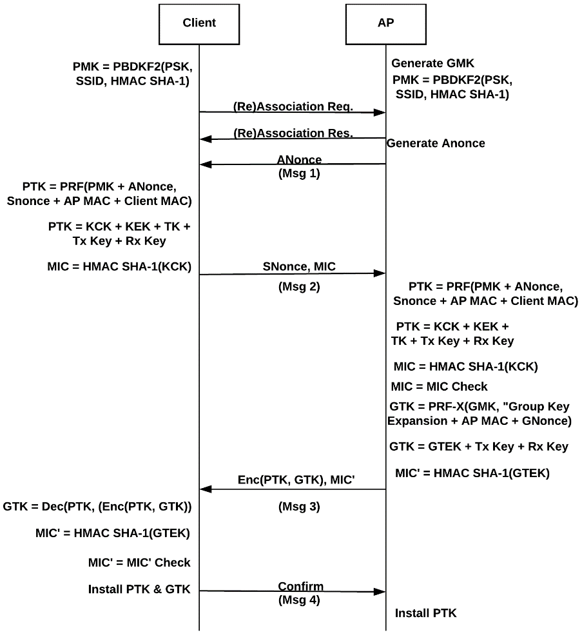
Figure 1. A detailed diagram of the four-way handshake Message.
A four-way handshake, demonstrated in Figure 1, is performed using the TKIP keys, resulting in a 512-bit key that is shared between the client and the access point. A 128-bit temporal key and two 64-bit MIC keys are derived from this 512-bit key. One MIC key is for the Access Point (AP) to client communication and the other for client to AP communication. The sender of a TKIP frame calculates the MIC value of each data packet using an algorithm, called the Michael algorithm, which takes the MIC and a secret key. The data packet concatenated with the MIC is then encapsulated using WEP so it can be implemented on old WEP hardware. An ICV is appended, then the packet is encrypted using RC4 and a key that uses the function that combines the temporal key, transmitter MAC address and the TKIP Sequence Counter (TSC). The receiver will check to see if the TSC is in order and the ICV is correct. If either of these checks are not valid, the frame will be dropped. The original data packet is reassembled, and the MIC value is verified. If it is accepted, the TSC replay counter is updated

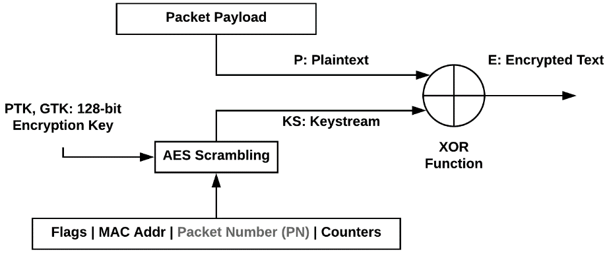
Figure 2. CCMP encryption diagram.
Counter Mode with Cipher Block Chaining Message Authentication Code Protocol (CCMP) is an encryption protocol that forms part of the 802.11i standard for wireless local area networks (WLANs), particularly those using WiMax technology. The CCMP algorithm is based on the U.S. federal government's Advanced Encryption Standard (AES). CCMP offers enhanced security compared with similar technologies such as Temporal Key Integrity Protocol (TKIP). CCMP employs 128-bit keys and a 48-bit initialization vector that minimizes vulnerability to replay attacks. The Counter Mode component provides data privacy. The Cipher Block Chaining Message Authentication Code component provides data integrity and authentication. The enhanced privacy and security of CCMP compared with TKIP requires additional processing power, often necessitating new or upgraded hardware.
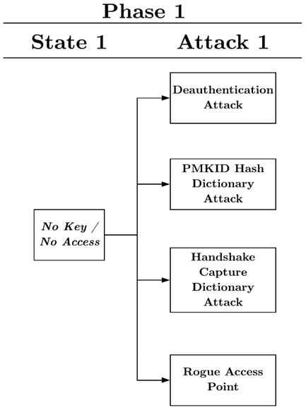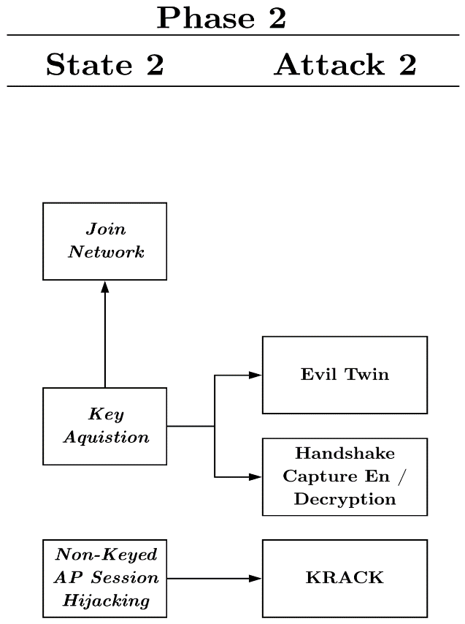
Figure 4. Phase 2: Deauth Attack
Figure 3. Phase 1: Attack Flow
Figure 3: Attack Flow:
The de-authentication attack is a straightforward attack that creates a Denial of Service (DoS) for one or many users. When a client wants to connect with an AP, it must first identify and authenticate itself to the AP. The AP will then send a response back to the client acknowledging the authentication. The client will then request an association with the AP and await the response for connection. Once those initial steps are completed, the client and AP will perform a four-way handshake to prove knowledge of the PSK and use it to derive keys for encryption. From that point on, the two devices can send encrypted data to each other. However, just as they can send authentication frames to each other, they can also send de-authentication frames to tell the other device to cut communication. De-authentication frames fall under the management frames category. Management frames are important system data packets sent from the AP to the client and vice versa.
Figure 4: Deauth Attack:
From the brute force/dictionary and rogue access point attacks preformed in this Section, the attacker has gained the passphrase to the AP. This will now allow the execution of the evil twin attack, as well as give the ability to legitimately join the network through the normal handshake process, as shown in Figure 4. Likewise, from this position, an adversary could monitor the air medium from packets being sent between clients and APs and, using the passphrase, can launch the handshake capture decryption attack.
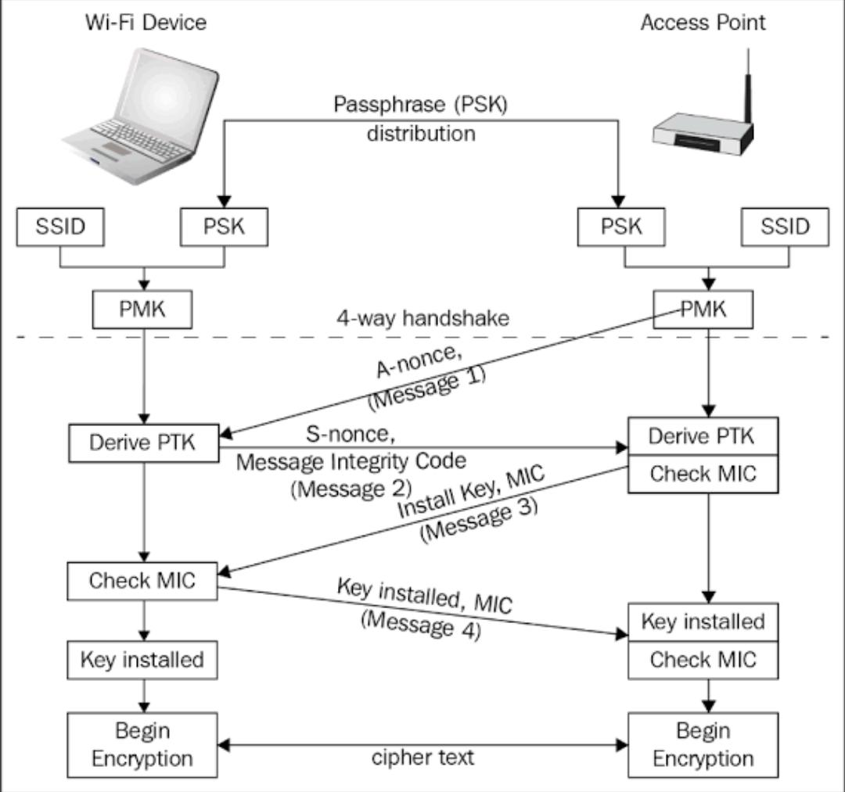
Figure 5: 4 Way Handshake Protocol

The four-way handshake is designed so that the access point (or authenticator) and wireless client (or supplicant) can independently prove to each other that they know the PSK/PMK, without ever disclosing the key. Instead of disclosing the key, the access point (AP) and client encrypt messages to each other that can only be decrypted by using the PMK that they already share and if decryption of the messages was successful, this proves knowledge of the PMK. The four-way handshake is critical for protection of the PMK from malicious access points for example, an attacker's SSID impersonating a real access point so that the client never has to tell the access point its PMK. A four-way handshake is used to establish another key called the Pairwise Transient Key (PTK). The PTK is generated by concatenating the following attributes: PMK, AP nonce (Nonce), STA nonce (SNonce), AP MAC address, and STA MAC address. The product is then put through a pseudo-random function. The handshake also yields the GTK (Group Temporal Key), used to decrypt multicast and broadcast traffic.
After understanding the authentication process and the four-way handshake, which was explained in detail in Section 2.3 and in Figure 1, we can discuss how an attacker can decrypt encrypted traffic by knowing the network key. Using a wireless adapter set to monitor mode and a traffic sniffing software, such as Wireshark, the attacker is able to view and capture all traffic flowing from a client to an AP and vice versa, being that the messages are sent through the air in a public medium. To a normal user, this traffic is useless because it is encrypted with a different PTK for each client generated by the four-way handshake upon connection. If the attacker, however, was able to capture the handshake upon connection for a particular client and has knowledge of the PSK, he/she would have enough information to derive the PTK for that client. The AP SSID and PSK are already known by the attacker to generate the PMK. The attacker will then capture the two nonce’s sent by the AP and the client and use them to derive the PTK, as shown in Figure 1. From there, the attacker could use the PTK, along with the CCMP protocol shown in Figure 2, to derive all messages for that session by the victim client and view the information being transmitted, as long as the attacker keeps track of the message counter from the beginning of the connection, which is used in the CCMP encryption. Therefore, this is how the attacker tries to capture the handshaking packet at the time of attack and with the help of the captured packet he tries to perform some of the set of attacks such as Brute force or Dictionary attacks that is done by giving the input as a wordlist which contains a list of permutations and combinations passwords that are randomly generated with the help of some algorithms so that it may help in cracking and getting the password of the victim respectively.

CHAPTER 6
INTERNSHIP OUTCOMES
The Final outcome of this project is the password hijacking which were cracked by using various tools like Wifite, Wifite2, Aircrack-ng etc. Understanding the workflow of different types of wlan devise such as its WLAN, WNIC, SSID, EAPOL, BSSID, Wireless AP etc. Understanding different wireless standards i.e. 802.11a/b/e/g/I/n. & and authentication standards such as WEP, EAP, PAP, KERBEROS and authentication server i.e. RADIUS (Remote Access Dial-In-User Service) etc.

Performing a wireless vulnerability assessment and exploiting discovered vulnerabilities. Gain privileged access to wireless systems using the latest hacking techniques. Interpret the results of the tools used during the assessment. Eradicate discovered vulnerabilities. Performing Authentication and De-authentication when in monitor / Injection Mode of respective Wi-Fi. Study of Security Measures and analysing the vulnerabilities that is more in which wi-fi device.

CHAPTER 7
SYSTEM REQUIREMENTS

7.1 Hardware Specifications
- Processor : Intel® Core™ CPU
- RAM : 2.0 GB
- System Type : 64-bit Operating System
- Hard Disk : 10 GB

7.2 Software Specifications
- Operating System : Kali Linux
- Tools Used : Aircrack-ng, Hashcat, Wifite/Wifite2

CHAPTER 8
CONCLUSION

Therefore, from the process outcomes of wireless hacking and security project which was presented and successfully carried out by various wireless hacking tools and possible attacks on wireless networks. Although wireless networks will probably never be completely secure because research on protocol vulnerabilities will always continue, one can keep their network as secure as possible. Staying educated on the latest encryption schemes and other network security related items is probably the best way to keep your network secure. You will not be able to stop the sniffing of your traffic; however, you can prevent the attacker from being able to decipher the traffic. The protocols will continue to evolve to keep unauthorized devices from connecting to a wireless network. However, even the latest security methods have their weaknesses. For example, WPA2, the latest encryption method, does not address the problem of dissociation and DE authentication attacks, but does address many of the issues with WEP. The attack tools are easy to obtain, easy to install, and have detailed web pages or forums that include directions on how to obtain, install and use. Many of the tools are multi-platform which makes it even easier to use. As the network security field grows in complexity, the attack tools will evolve. So, with the help of those Wi-Fi cracking tools we can achieve in hacking the wireless devices passwords respectively.

CHAPTER 9
REFERENCES
- www.searchsecurity.techtarget.com
- www.cybrary.it
- http://sectools.org/wireless.html
- https://www.cybrary.it/0p3n/crack-wpawpa2-wi-fi-passwords-using-aircrack-ng/
- http://blogs.ittoolbox.com/wireless/networks/archives/wireless-man-in-the-middle-attack-part-ii-7421
- http://www.wi-foo.com/index-2.html
- http://www.networkdictionary.com/security/Widely.php
- https://medium.com/@brannondorsey/crack-wpa-wpa2-wi-fi-routers-with-aircrack-ng-and-hashcat-a5a5d3ffea46

APPENDIX A: -Steps to follow in wireless hacking via Command terminal

Step-1: -
First open terminal. We need to know the name of the wireless adapter connected to the computer because computer has many adapters connected. So, we use command: iwconfig.
Step 2: -
For some wireless cards, it gives error messages to enable monitor mode on wireless cards. For that, you should use airmon-ng check kill.
Step 3: -
Enable monitor mode by using the command: airmon-ng start wlan0(interface of wireless card).
Now this command will enable the monitor mode on the Wi-Fi card. So, while using interface in any terminal or command line use wlan0mon.
Step 4: -
We need to use the command airodump-ng wlan0mon, this will display all the access points in your surroundings and also the clients connected to that access points. Now this command captures the packets in the air. This will gather data from the wireless packets in the air.
Note: Do not close this terminal. This will be used to know wpa has been captured or not.
Step 5: -
In this step we will add some parameters to airodump-ng.
command is airodump-ng -c channel –bssid [bssid of wifi] -w [path to write the data of packets] wlan0mon[interface].
-bssid in my case bssid is indicated with red mark.
-c channel is the channel of victim wifi in my case it is 10(see in previous screenshot for channel number)
-w It is used to write the captured data to a specified path in my case it is ‘/root/Desktop/hack’.
Interface in my case is wlan0mon.
In the above command the path /root/Desktop/hack. Where hack is the name of the file to be saved.
Step 6: -
In this step we DE authenticate the connected clients to the Wi-Fi. The command is: aireplay-ng –deauth 10 -a [router bssid] interface. In the above command it is optional to give the client mac address it is given by -c <client mac>

This will disconnect the client from access point. Screenshot of a client connected to AP shown below.
After this the client tries to connect to the Wi-Fi again. At that time, we will capture the packets which sends from client. From this result, we will get wpa handshake.
Step 7: -
Now we should start cracking the Wi-Fi with captured packets command for this is: -
aircrack-ng -b [bssid of router] -w [path to word list] [path to capture packets]
-w path to word list in my case it is ‘/root/Desktop/wordlist.txt’
If you did not have word list, get one. If you want to generate your custom wordlist, you can visit our other post: How generate word list using crunch.
Now press enter aircrack will start cracking the Wi-Fi. Later,
It’ll show as Aircrack cracked Wi-Fi and key found.
Note: To use this method you need to have wordlist compulsory there are many wordlists available in internet you can download them.

APPENDIX B: Snapshots
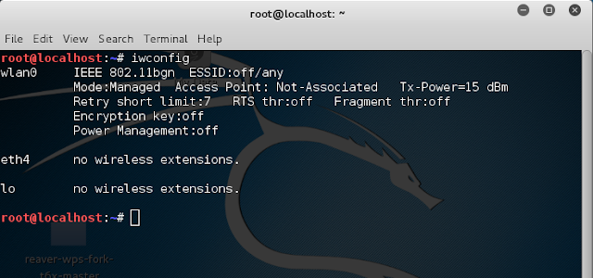
Fig6: Step1 iwconfig

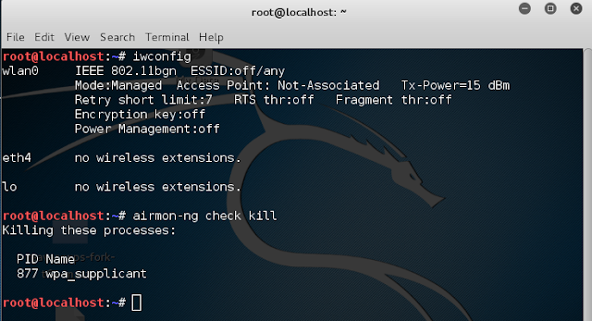
Fig7: Step2 airmon-ng check kill.

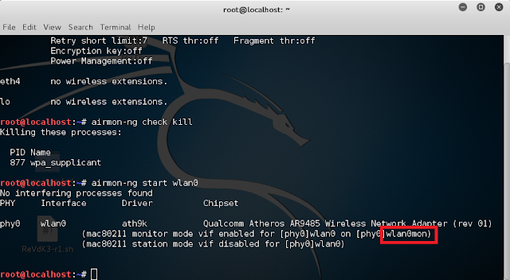
Fig8: Step3 wlan0mon.

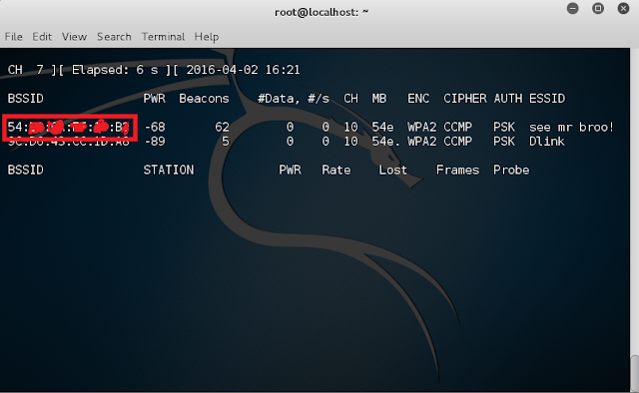
Fig9: Step4 airodump-ng wlan0mon

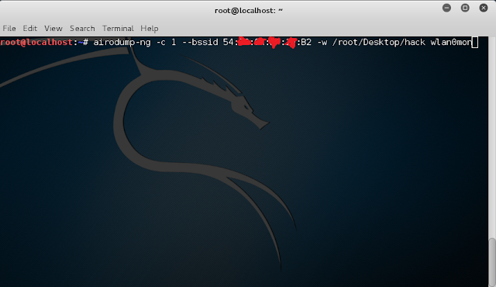
Fig10: Step5 airodump-ng.

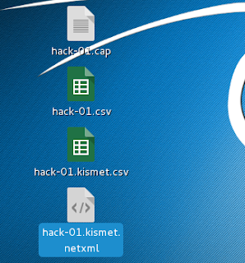
Fig11: Step5 hack-01. kismet.netxml file is created

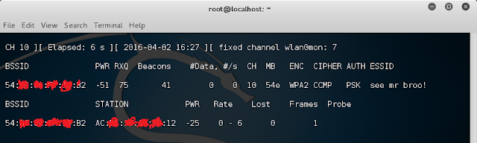
Fig12: Step5 Tracking BSSID

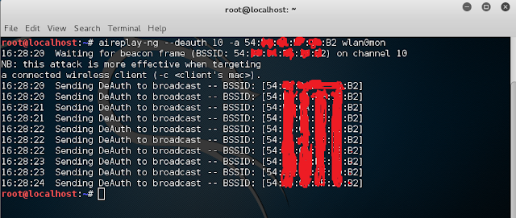
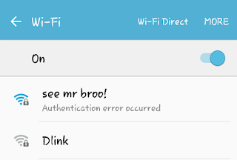
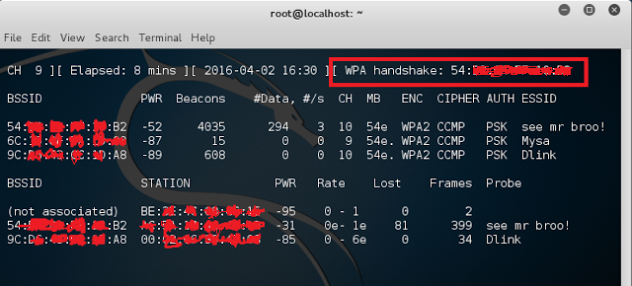
Fig13: Step6 DE authenticate the connected clients to the Wi-Fi
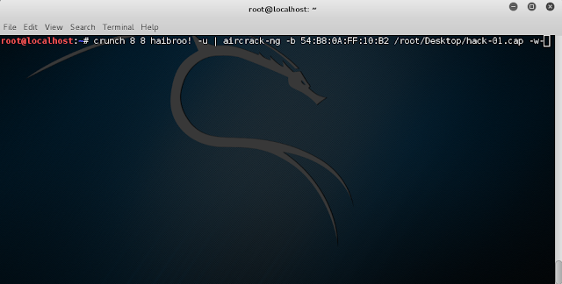
Fig14: Step7 cracking the Wi-Fi with captured packets

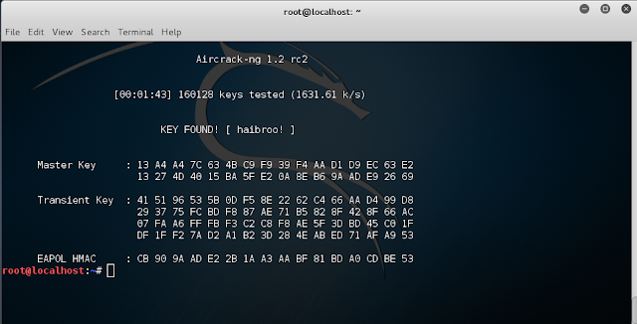
Fig15: Step7 key found

